**CSC 101: Introduction to Computer Science Revision and Study Guide**

1. This computer component holds processed information before it is output. a). RAM.

1. ROM.
2. bus.
3. ports

**Answer: a**

2. _____refers to the physical or logical arrangement of a network. a) Data flow

1. Mode of operation
2. Topology
3. Architecture
4. None of them **Answer: c**

3. What is the technique in shared systems that avoids mixing printout from several programs called? a) Paging

1. Slicing
2. Queuing
3. Spooling **Answer: d**

4. This coding system is designed to support international languages like Chinese and Japanese.

1. ASCII
2. Unicode
3. EBCDIC
4. ANSI **Answer: b**

5. A letter, digit, or special character is represented by a code in a a) bit

1. byte
2. kilobyte
3. megabyte **Answer: b**

6. The representation of positive numbers in sign-and-magnitude, one's complement, and two's complement are all identical.

1. True
2. False

**Answer: a**

7. A programming error that occurs when running a program produces incorrect results. a) logic error

1. syntax error
2. run time error
3. linker error **Answer: a**

8. This computer term is used to describe the number of bits that a CPU accessed at one time.

1. Nibble
2. word
3. byte
4. character

**Answer: b**

9. Visual Basic is a tool that allows you to develop application in _____ a) Real time

1. Graphical User Interface
2. Character User Interface
3. None of These **Answer: b**

10. The Properties window plays an important role in the development of Visual Basic applications. It is mainly used ______

1. To change how objects look and feel
2. When opening programs stored on a hard drive
3. To allow the developer to graphically design program components
4. To set program related options like Program Name, Program Location, etc. **Answer: a**

11. A VBA unit is called a ______

1. Subroutine
2. Routine
3. Macro
4. Program

**Answer: c**

12. In visual basic the declaration of variables is done by _____ key word. a) int

1. dim
2. static
3. declare

**Answer: b**

13. To declare an integer variable in VB.NET language, which one of the following statements is true? a) Dim x As Single

1. Dim x As Integer
2. c. x As Integer
3. None of the mentioned **Answer: b**

14. VB.Net is_____

1. Platform Independent
2. Compiler Language
3. Forward compatible
4. Backward compatible

**Answer: d**

15. VB.Net supports_____

1. Structured error handling
2. Unstructured error handling
3. Both
4. None

**Answer: a**

16. Visual Studio .NET provides which feature:

1. Debugging
2. application deployment
3. syntax checking
4. All of the above

**Answer: d**

17. Which of the following are NOT true about .NET Framework?

1. It provides a consistent object-oriented programming environment whether object code is stored and executed locally, executed locally but Internet-distributed, or executed remotely.
2. It provides a code-execution environment that minimizes software deployment and versioning conflicts.
3. It provides a code-execution environment that promotes safe execution of code, including code created by an unknown or semi-trusted third party.
4. It provides different programming models for Windows-based applications and Web-based applications.
5. It provides an event driven programming model for building Windows Device Drivers. a) 1, 2
6. 2, 4
7. 4, 5
8. 1, 2, 4

**Answer: c**

18. Which of the following constitutes the .NET Framework?

1. ASP.NET Applications
2. CLR
3. Framework Class Library
4. WinForm Applications 5. Windows Services
5. 1, 2
6. 2, 3
7. 3, 4
8. 2, 5

**Answer: b**

19. Point out the wrong statement.

1. The goal of dotConnect for SQL Server is to enable developers to maintain database applications
2. dotConnect for SQL Server combines connected and disconnected data access models in single

SqlDataTable component

1. dotConnect for SQL Server supports new ADO.NET features and technologies as soon as they are released d) None of the mentioned **Answer: a**

Explanation: The goal of dotConnect for SQL Server is to enable developers to write efficient and flexible database applications. The dotConnect for SQL Server assemblies are implemented using optimized code and advanced data access algorithms.

20. __________object is used to fill a DataSet/DataTable with query results in ADO.net. a) DataReader

1. Dataset
2. DataAdapter
3. DataTables **Answer: c**

Explanation: A DataAdapter object can be thought of as the adapter between the connected and disconnected data models.

21. Set of buttons that invoke commands in a computer word processing document is called______ a) menu

1. button list
2. dialog
3. toolbar

**Answer: d**

22. Computer command which issued to move selected text to another part of a document is______ a) copy and position

1. drag and drop
2. find and replace
3. cut and paste

**Answer: b**

23. Amount of vertical space between lines of computer text is determined by______ a) paragraph spacing

1. word spacing
2. line spacing
3. text spacing

**Answer: c**

**THEORY**

1. What is an operating system? What are the main functions of an operating system? Provide examples of operating systems.

A collection of programs that manage and coordinate the activities taking place within a computer system

Definition: A set of programs that lies between applications software (i.e., user) and the hardware. We said that OS is a set of programs. The most important program in OS is the Kernel

**Functions:-**

* User Interface
* Booting the computer
* Kernel is loaded into memory Processes are started
* Configuring devices
* Device drivers are often needed; can be reinstalled if needed
* Plug and Play devices are recognized automatically
* Program Execution
* Managing resources and jobs
* Makes resources available to devices Monitors for problems
* Scheduling routines File management
* Create, rename, delete, and move files and folders Security Passwords. Examples: windows7 windows server 2013 window xp

1. Explain what is meant by disk-scheduling? Name and describe briefly three disk-scheduling algorithms.

**Disk-scheduling algorithms** determine the order in which pending disk requests are processed. First-come, first-served disk scheduling takes all requests in order but is not very efficient. Shortest-seek-time-first disk scheduling is more efficient but could suffer from starvation. SCAN disk scheduling employs the same strategy as an elevator, sweeping from one end of the disk to the other.

1. Write in your own words about Multimedia data representation inside computers.

Computers are multimedia devices that manipulate data varying in form from numbers to graphics to video. Because a computer can only manipulate binary values, all forms of data must be represented in binary form. Data is classified as being continuous (analog) or discrete (digital). Integer values are represented by their binary equivalent, using one of several techniques for representing negative numbers, such a sign magnitude or oneÕs complement. Real numbers are represented by a triple made up of the sign, the digits in the number, and an exponent that specifies the radix point. A character set is a list of alphanumeric characters and the codes that represent each one. The most common character set is Unicode (16 bits for each character), which has ASCII as a subset. The 8-bit ASCII set is sufficient for English but not for other (or multiple) languages. There are various ways for compressing text so that it takes less space to store it or less time to transmit it from one machine to another.

Audio information is represented as digitized sound waves. Color is represented by three values that represent the contribution of each of red, blue, and green. There are two basic techniques for representing pictures, bitmaps and vector graphics. Video is broken up into a series of still images, each of which is represented as a picture

1. What is VBA?

VBA stands for Visual Basic for Applications. VBA is Programming language available in MS Office Tools, an event driven programming language developed by Microsoft. It is predominantly used with Microsoft office applications like MS-word, MS-Access, and MS-Excel.

1. What are the benefits of using the VB.NET programming language? Benefits of using the VB.NET programming language • It is totally object-oriented.
   * VB.Net handles pointers indirectly and helps develop more secure and stable applications.
   * Managed code execution runs under the Common Language Runtime (CLR) that results in robust and secure applications.
   * It supports optional parameters which make COM interoperability very easy.
   * In VB.NET, the CLR takes care of garbage collection. It releases resources as soon as an object is no more in use. So, developers need not worry about memory management.

1. What are Data-types?

Data types helps to declare Variables with specific data, this helps to VBA to know the type of the data and assign the memory based on the DataType of the Variable.

1. Name 5 data types? 
   * Boolean
   * Byte
   * Currency
   * Date
   * Double
   * Integer
   * Long
   * LongLong
   * LongPtr
   * Object
   * Single
   * String
   * Variant

1. What is namespace? Which namespace is used for accessing the data?

A namespace is an organized way of representing Class, Structures and interfaces present in .NET language.

Namespaces are hierarchically structured index of a class library, available to all .NET Languages. System.Data namespace is used for accessing and managing data from the required data source. This namespace deals only with the data from the specified database.

1. What is the difference between ADO and ADO.NET?

Following are the differences between ADO and ADO.NET:

|  |  |
| --- | --- |
| **ADO** | **ADO.Net** |
| It is a COM based library. | It is a CLR based library. |
| Classic ADO requires active connection with the data store. | ADO.NET architecture works while the data store is disconnected. |
| Locking feature is available. | Locking feature is not available. |
| Data is stored in binary format | Data is stored in XML. |
| XML integration is not possible. | XML integration is possible. |
| It uses the object named Record set to reference data from the data store. | It uses Dataset Object for data access and representation. |
| Firewall might prevent execution of Classic  ADO. | ADO.NET has firewall proof and its execution will never be interrupted |
| Classic ADO architecture includes client-side cursor and server-side cursor. | ADO.NET architecture doesn't include such cursors. |
| We cannot send multiple transactions using a single connection instance | We can send multiple transactions using a single |

1. Define the following terms: "storage", "storage medium", "storage devices", “reading" and "writing".

* **Storage** is the place where data is held in an electromagnetic or optical form for access by a computer processor.
* **A Storage Medium** is any technology (including devices and materials) used to place, keep, and retrieve data. A medium is an element used in communicating a message; on a storage medium, the "messages" - in the form of data - are suspended for use when needed. The plural form of this term is storage media. Although the term storage includes both primary storage (memory), a storage medium usually means a place to hold secondary storage such as that on a hard disk or tape.
* **A Storage device** is any hardware capable of holding information either temporarily or permanently. There are two types of storage devices used with computers: a primary storage device, such as RAM, and a secondary storage device, like a hard drive. Secondary storage can be removable, internal, or external storage.
* **Writing** is a method of representing language in visual or tactile form. Writing systems use sets of symbols to represent the sounds of speech, and may also have symbols for such things as punctuation and numerals. **Reading** is a complex cognitive process of decoding symbols in order to construct or derive meaning (reading comprehension). Reading is a means of language acquisition, of communication, and of sharing information and ideas. Like all languages, it is a complex interaction between the text and the reader which is shaped by the reader’s prior knowledge, experiences, attitude, and language community which is culturally and socially situated.

1. Complete the following table to reflect how computer storage is measured:

|  |  |  |
| --- | --- | --- |
| **Storage Term** | **Value in Base 2** | **Exact Numbers in Bytes** |
| **Kilobyte (KB)** | 210 | 1024 |
| **Megabyte (MB)** | 220 | 1,048,576 or 10242 |
| **Gigabyte (GB)** | 230 | 1,073,741,824 or 10243 |
| **Terabyte (TB)** | 240 | 1,099,511,627,776 or 10244 |
| **Petabyte** | 250 | 1,125,899,906,842,624 or 10245 |

1. Convert each digit to its equivalent Base representation:

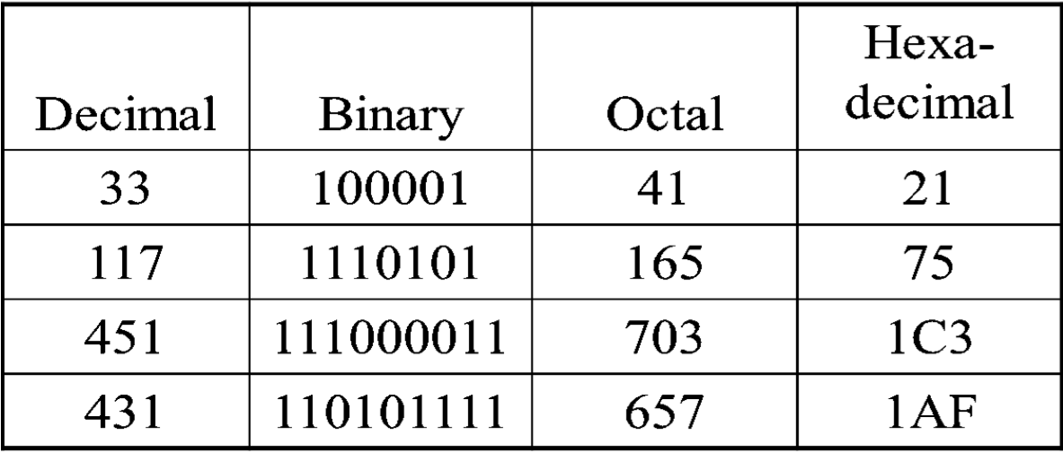

1. Programming languages are classified into five main generations, explain them and give examples.
2. **1GL or first-generation language** was (and still is) machine **language** or the level of instructions and data that the processor is actually given to work on (which in conventional computers is a string of 0s and 1s). Machine language is a set of instructions and data that a computer's central processing unit can execute directly. Machine language statements are written in binary code, and each statement corresponds to one machine action.
3. **2GL or second-generation language** is **assembler** (sometimes called "assembly") **language**. Assembly language is the human-readable notation for the machine language used to control specific computer operations. An assembly language programmer writes instructions using symbolic instruction codes that are meaningful abbreviations or mnemonics. An assembler is a program that translates assembly language into machine language
4. **3GL or third-generation language** is a "high-level" programming language or procedural language uses a series of English-like words that are closer to human language, to write instructions. High-level programming languages make complex programming simpler and easier to read, write and maintain. Programs written in a high-level programming language must be translated into machine language by a compiler or interpreter. **PASCAL, FORTRAN, BASIC, COBOL, C and C++** are examples of third generation programming languages
5. **4GL or fourth-generation language** is designed to be closer to natural language than a 3GL language. Languages for accessing databases are often described as 4GLs. The fourth generation programming language or non-procedural language, often abbreviated as 4GL, enables users to access data in a database. A very high-level programming language is often referred to as goaloriented programming language because it is usually limited to a very specific application and it might use syntax that is never used in other programming languages. **SQL, NOMAD and FOCUS** are examples of fourth generation programming languages.
6. **5GL or fifth-generation language** is programming that uses a visual or graphical development interface to create source language that is usually compiled with a 3GL or 4GL language compiler. Microsoft, Borland, IBM, and other companies make 5GL visual programming products for developing applications in Java, for example. **Visual programming** allows you to easily envision **object-oriented programming** class hierarchies and drag icons to assemble program components.

14. What is the main difference between a compiled and an interpreted program?

The difference is not in the language; it is in the implementation, In a **Compiled Program** implementation, the original program is translated into native machine instructions, which are executed directly by the hardware. In an **Interpreted Program** implementation, the original program is translated into another program, called "the interpreter", then examines the instruction and performs whatever actions are called for. Depending on the language and its implementation, there are a variety of forms of Instructions. Interpreted languages are code is translated to machine instructions step-by-step while the program is being executed, while compiled languages have code has been translated before program execution.

15.

Outline and Describe Five (5) of the commonly used flowchart symbols and their functions.

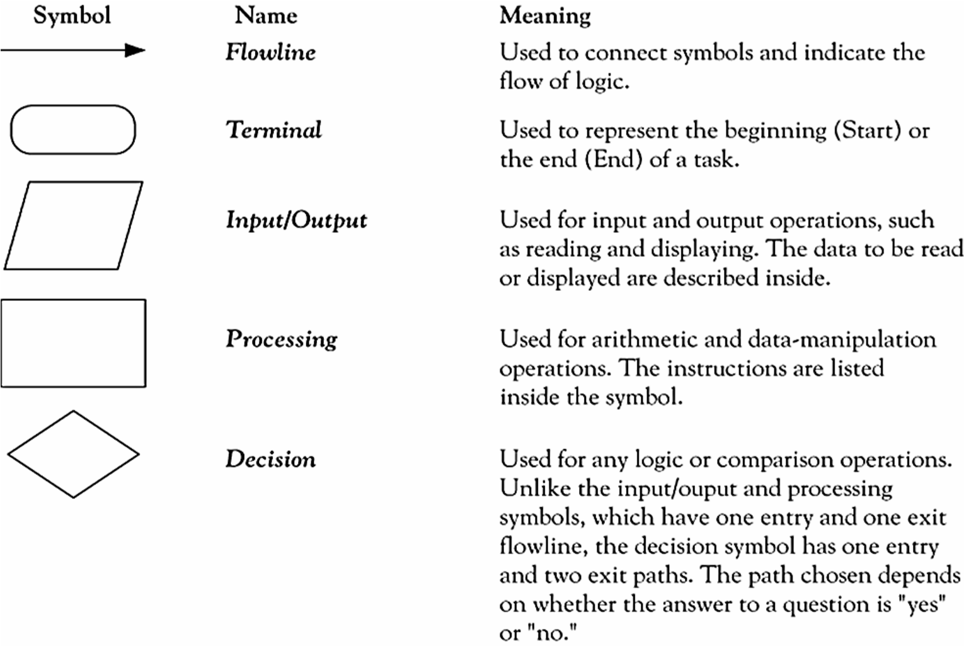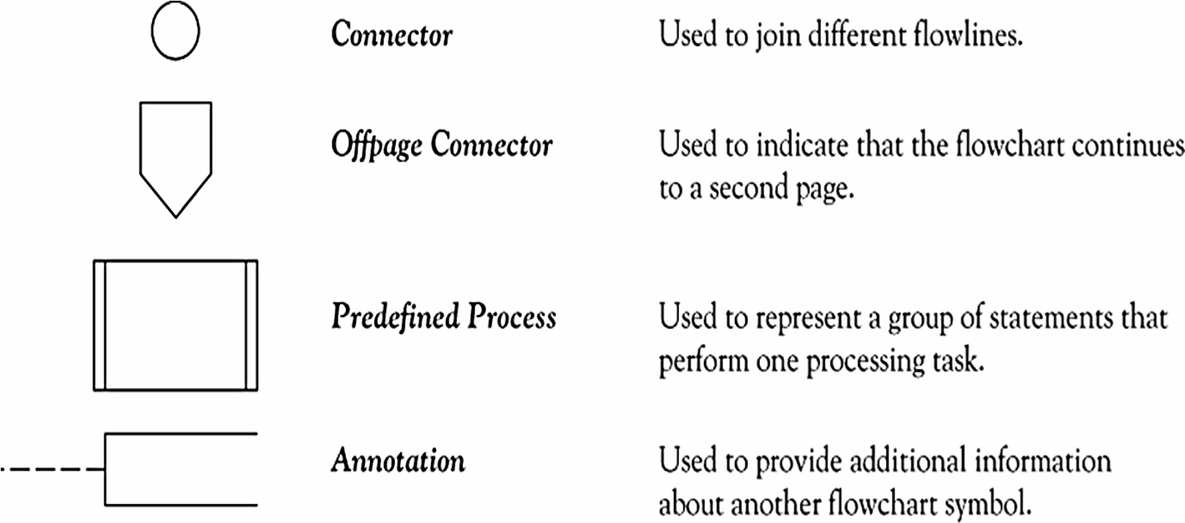

1. Store +7 in an 8-bit memory location using 1’s complement representation.

First change the number to binary 111

Add five 0s to make a total of N (8) bits, 00000111

The sign is positive, so no more action is needed

The result is: 00000111

1. Represent -5 in binary using 2’s complement notation.

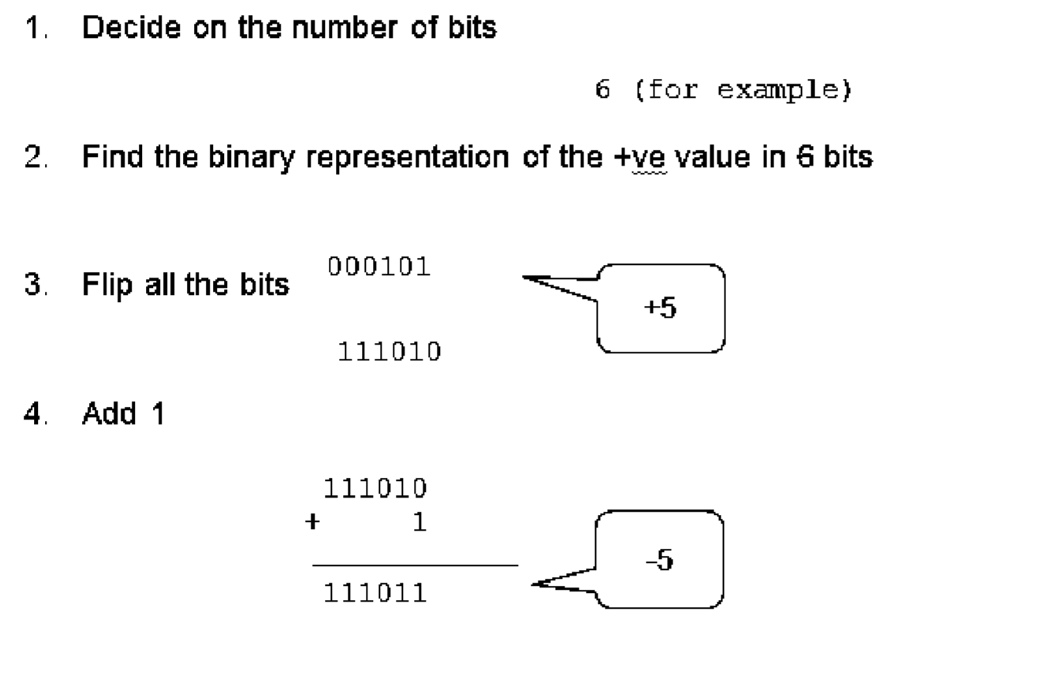

1. Write the Pseudocode to read values for three variables. U, V, and W and find a value for RESULT from the formula: RESULT = U + V2/W. Draw the flowchart.

**Pseudocode:**

Step 1: Input values for U, V, and W

Step 2: Computer value for result

Step 3: Print value of result Step 4: Stop

**Flowchart:**

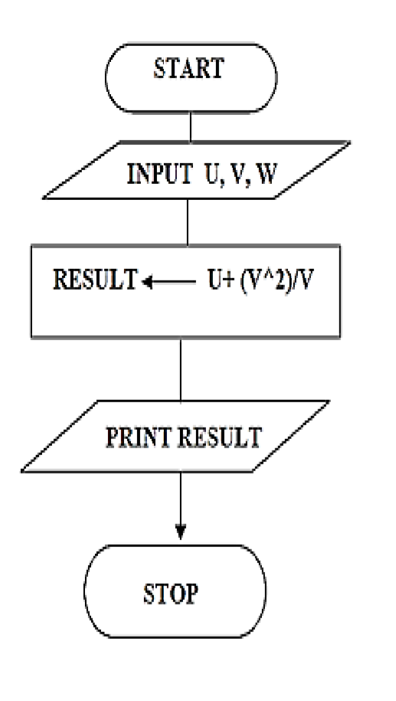

1. Describe the basic features of C++ Programming language 
   1. **Better memory management –** you can dynamically allocate memory during runtime using new and delete operator in C++ to have better memory management.
   2. **Object oriented –** C++ supports object oriented programming features, which means we can use the popular OOPs concepts such as Abstraction, Inheritance, Encapsulation and Inheritance

in C++ programs, these features make writing code in C++ a lot easier. We will cover them in detail in this tutorial series.

* 1. **Portable –** Most of C++ compilers supports ANSI standards that makes C++ portable because the code you write on one operating system can be run on other Operating system without making any change. We cannot say C++ a fully platform independent language as certain things in C++ are not portable, such as drawing graphics on a screen, since standard C++ has no graphics or GUI API.
  2. **Structured programming language –** We have functions in C++, which makes easier to break a problem into small blocks of code and structure the program in such a way so that it improves readability and reusability.
  3. **Exception handling:** Just like Java we can do exception handling in C++ which makes it easier to identify and handle the exceptions.
  4. **Simple –** Last but not least, just like C, it is easier to write a program in C++. Once you get familiar with the syntax of C++ programming language, it becomes a lot easier to code in C++.